2022 FIRCREST COMMUNITY SPONSORSHIP PROGRAM

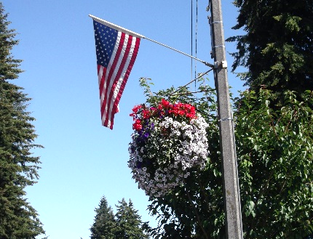
It’s time again to consider participating in the Fircrest Community Sponsorship Program, an opportunity for residents and local businesses to support our community by sponsoring certain beautification projects, such as the entry island plantings and flowers. This sponsorship program started in the year 2000 to kick off our 75th Anniversary as a community and has grown to a huge success over the years.

Your donation does make a difference! Over the past years, the City has received many compliments on the Regents Boulevard hanging baskets, the fabulous fireworks display at Fun Days, banners & flags and other beautification projects. You can help us make your donations more meaningful by giving us ideas for future City beautification projects. List your ideas on the back of the donation form. We can all make a difference by working together.

Each donation will receive recognition in a future mailing to the residents. Donations may be dedicated in memory of a loved one or in celebration of a special event. To participate, complete the form below and return it to City Hall with a check made payable to the Fircrest Sponsorship Program.

THANK YOU FOR YOUR PARTICIPATION!

Brett L. Wittner, Mayor Scott Pingel, City Manager

Please print clearly as you would like published. Check if you do not want your name published.

Name:

Address:

I wish to sponsor:

# Hanging Basket(s) at $50.00 each for a total of $

Fircrest Beautification: $10.00 $15.00 $20.00 Other $

Fun Days Fireworks Display: $10.00 $15.00 $20.00 Other $

Please circle one: In memory of… In celebration of…

(32 letter limit, please)

You may return this form and your donation via:
- Include it with your utility payment in the envelope provided, (separate checks, please); or
- Drop it off at City Hall or mail to: 2022 Fircrest Community Sponsorship Program
City of Fircrest
115 Ramsdell Street
Fircrest, WA 98466

