CITY OF FIRCREST
RESOLUTION NO. 1764

A RESOLUTION OF THE CITY COUNCIL OF THE CITY OF FIRCREST, WASHINGTON, AUTHORIZING THE CITY MANAGER TO EXECUTE A GRANT CONTRACT WITH THE UNITED STATES DEPARTMENT OF JUSTICE’s OFFICE OF JUSTICE PROGRAMS AND JUSTICE & SECURITY STRATEGIES, INC. TO ACCEPT THE GRANT IN THE AMOUNT OF $18,000 FOR THE IMPLEMENTATION OF BODY-WORN CAMERA (BWC) PROGRAMS FOR SMALL, RURAL, AND TRIBAL LAW ENFORCEMENT AGENCIES (SRT).

WHEREAS, the City was successful in being awarded $18,000 for the implementation of body-worn camera (BWC) programs for small, rural, and tribal law enforcement agencies; and

WHEREAS, the City is continuously moving in the direction of transparency; and

WHEREAS, the City desires to provide accountability for police activities, have an additional de-escalation tool, and provide evidence for the investigation or prosecution of crimes.

NOW, THEREFORE, BE IT RESOLVED BY THE CITY COUNCIL OF THE CITY OF FIRCREST:

Section 1. The City Manager is hereby authorized and directed to execute a grant contract with the United States Department of Justice’s Office of Justice Programs and Justice & Security Strategies, Inc. in the amount of $18,000 for funding the implementation of the body-worn camera program.

Section 2. Effective Date. This Resolution shall take effect and be in full force immediately upon its adoption.

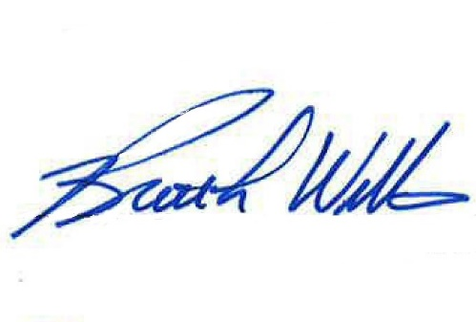
APPROVED AND ADOPTED BY THE CITY COUNCIL OF THE CITY OF FIRCREST, WASHINGTON, at a regular meeting thereof this 12th day of April 2022.

APPROVED:

_____________________________
Brett L. Wittner, Mayor

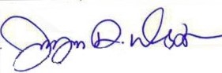
ATTEST:

_____________________________
Jayne Westman, City Clerk

APPROVED AS TO FORM:
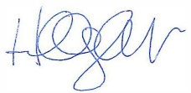
_____________________________
Hillary J. Evans, City Attorney

