CITY OF FIRCREST
RESOLUTION NO. 1767

A RESOLUTION OF THE CITY COUNCIL OF THE CITY OF FIRCREST, WASHINGTON, AUTHORIZING THE CITY MANAGER TO EXECUTE THE SYSTEM ACCESS AND USE AGREEMENT BETWEEN PIERCE COUNTY AND THE CITY OF FIRCREST.

WHEREAS, the City of Fircrest believes it to be in the best interest of our citizens to continue to contract with Pierce County for City and County radio coverage and communication infrastructure; and

WHEREAS, the City of Fircrest Police Department desires access to the Single County-Wide Communication System for public safety, first responder, and public service communications, and to use its approved mobile and portable radios and associated approved equipment.

NOW, THEREFORE, BE IT RESOLVED BY THE CITY COUNCIL OF THE CITY OF FIRCREST:

Section 1. The City Manager is hereby authorized and directed to execute the System Access and Use Agreement between Pierce County and the City of Fircrest from January 1, 2022, through December 31, 2022.

APPROVED AND ADOPTED BY THE CITY COUNCIL OF THE CITY OF FIRCREST, WASHINGTON, at a regular meeting thereof this 10th day of May 2022.
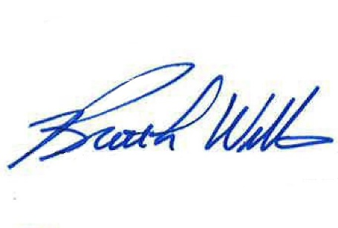
APPROVED:

_____________________________ Brett L. Wittner, Mayor

ATTEST:
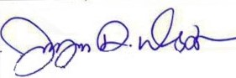

_____________________________
Jayne Westman, City Clerk

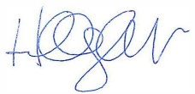
APPROVED AS TO FORM:

____________________________
Hillary J. Evans, City Attorney

