CITY OF FIRCREST
RESOLUTION NO. 1766

A RESOLUTION OF THE CITY COUNCIL OF THE CITY OF FIRCREST, WASHINGTON AMENDING THE PERSONNEL POLICIES AND PROCEDURES MANUAL FOR EMPLOYEES OF THE CITY OF FIRCREST TO INCLUDE JUNE 19TH, ALSO KNOWN AS JUNETEENTH, AS A RECOGNIZED, PAID HOLIDAY.

WHEREAS, the City Council of the City of Fircrest wishes to recognize June 19th as the date that commemorates the end of slavery in the United States; and

WHEREAS, since its origin in 1865 in Galveston, Texas, the observance of June 19th (Juneteenth) as the African American Emancipation Day has spread across the United States and beyond; and

WHEREAS, the City Council desires to include the Juneteenth Holiday as a recognized, paid holiday at the City of Fircrest, and include it in the Personnel Policies and Procedures Manual.

NOW, THEREFORE, BE IT RESOLVED BY THE CITY COUNCIL OF THE CITY OF FIRCREST:

Section 1. The Personnel Policies and Procedures Manual, as established by Resolution No. 1637, is hereby amended to add the Juneteenth Holiday as a recognized, paid holiday, as attached hereto.

Section 2. This resolution shall become effective April 27, 2022.

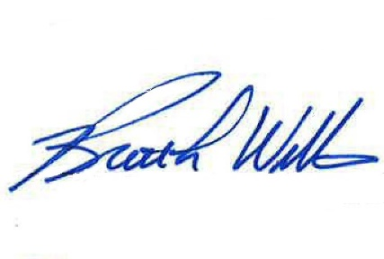
APPROVED AND ADOPTED BY THE CITY COUNCIL OF THE CITY OF FIRCREST, WASHINGTON, at a meeting thereof this 26th day of April 2022.

APPROVED:

______________________________
Brett L. Wittner, Mayor

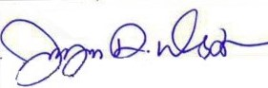
ATTEST:

___________________________________
Jayne Westman, City Clerk

APPROVED AS TO FORM:
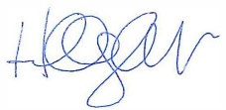
___________________________________
Hillary J. Evans, City Attorney

