CITY OF FIRCREST
ORDINANCE NO. 1684

AN ORDINANCE OF THE CITY OF FIRCREST, WASHINGTON, AMENDING FMC 2.44.150, RELATING TO HOLIDAYS; PROVIDING FOR SEVERABILITY; AND ESTABLISHING AN EFFECTIVE DATE

WHEREAS, the City Council of the City of Fircrest wishes to recognize June 19th as the date that commemorates the end of slavery in the United States; and

WHEREAS, since its origin in 1865 in Galveston, Texas, the observance of June 19th (Juneteenth) as the African American Emancipation Day has spread across the United States and beyond; and

WHEREAS, the City Council desires to include the Juneteenth Holiday as a recognized, paid holiday at the City of Fircrest.

THE CITY COUNCIL OF THE CITY OF FIRCREST DO ORDAIN AS FOLLOWS:

Section 1. FMC 2.44.150, Amended. Fircrest Municipal Code Section 2.44.150, Holidays, adopted in Ordinance No. 1636, is hereby amended to read as follows:

2.44.150 Holidays.

(a) The following are recognized as paid holidays:
New Year’s Day – January 1
Martin Luther King, Jr.’s Birthday – 3rd Monday in January
Presidents’ Day – 3rd Monday in February
Memorial Day – Last Monday in May
Juneteenth – June 19th
Independence Day – July 4
Labor Day – 1st Monday in September
Veteran’s Day – November 11
Thanksgiving Day – 4th Thursday in November
Friday following Thanksgiving
Christmas Day – December 25

Any holiday falling on Saturday will be celebrated on the preceding Friday. Any holiday falling on Sunday will be celebrated on the following Monday. The employee must be on paid status the day prior and day after a holiday to qualify for holiday payment.

(b) Floating Holiday. In addition to the above holidays, each regular full-time employee
shall be granted eight hours’ floating holiday time each calendar year; provided the
employee has worked or is scheduled to work four consecutive months in the calendar year. Accumulated holiday time shall be taken in the year it is accrued, or lost.
(c) Date Holiday Observed. Any holiday falling on a Saturday will be celebrated the
preceding Friday. Any holiday falling on a Sunday will be celebrated the following
Monday.
(d) Condition of Payment. As a condition to payment for the holidays, an employee must
be in a paid status the scheduled workday immediately preceding a holiday and the
scheduled workday immediately following the holiday, unless excused by the city
manager.
(e) Regular Part-Time Employees. A regular part-time employee is not entitled to
compensation for a holiday unless the day it is observed falls on the employee’s
regularly scheduled workday. Regular part-time employees will be paid on a pro-rata
basis based on the established number of hours in their work week.
(f) Holiday Work. Nonexempt regular full-time or part-time employees will be paid for
the holiday plus two times their regular rate of pay for any time worked on the
holiday. Such time must be preauthorized by the city manager and/or his/her
designee.
(g) Religious Holidays. If an employee’s religious beliefs require observance of a holiday not included in the basic holiday schedule, the employee may, with the city manager and/or his/her designee’s approval, take the day off using vacation, floating holiday, or leave without pay.

Section 2. Severability. Should any section, paragraph, sentence, clause or phrase of this Ordinance, or its application to any person or circumstance, be declared unconstitutional or otherwise invalid for any reason, or should any portion of this Ordinance be pre-empted by state or federal law or regulation, such decision or pre-emption shall not affect the validity of the remaining portions of this Ordinance or its application to other persons or circumstances.

Section 3. Effective Date. This Ordinance shall be published in the official newspaper of the City, and shall take effect and be in full force five (5) days after the date of publication.

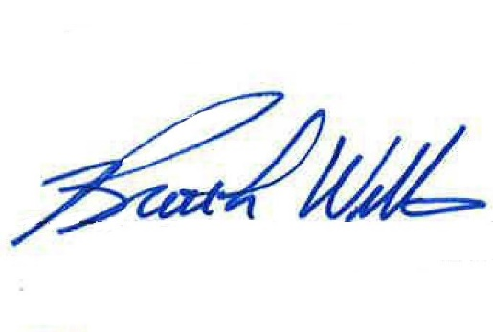
PASSED BY THE CITY COUNCIL OF THE CITY OF FIRCREST, WASHINGTON, at a regular meeting thereof this 26th day of April 2022.

APPROVED:

___________________________________ Brett L. Wittner, Mayor

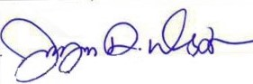
ATTEST:

___________________________________
Jayne Westman, City Clerk

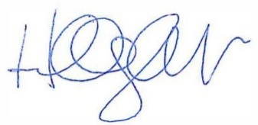
APPROVED AS TO FORM:

___________________________________

Hillary J. Evans, City Attorney

DATE OF PUBLICATION:

EFFECTIVE DATE:

