CITY OF FIRCREST

ORDINANCE NO. 1683

AN ORDINANCE OF THE CITY OF FIRCREST, WASHINGTON, AMENDING ORDINANCE NO. 1679 TO AUTHORIZE ADDITIONAL EXPENDITURES OF FUNDS FOR MATTERS NOT FORESEEN AT THE TIME OF FILING THE ANNUAL BUDGET FOR 2022; AND ESTABLISHING AN EFFECTIVE DATE.

WHEREAS, the City anticipates certain revenues and expenditures not foreseen at the time of filing the Annual Budget for 2022; and;

WHEREAS, the City of Fircrest adopts an annual budget at the fund level and;

WHEREAS, the City of Fircrest adopted its 2022 Budget on November 9,2021 through Ordinance #1679 and;

WHEREAS, it is necessary to amend the adopted 2022 budget to defray the anticipated expenditures; Now, Therefore,

THE CITY COUNCIL OF THE CITY OF FIRCREST DO ORDAIN AS FOLLOWS:

Section 1. The revenues and expenditures set forth in Section 2 below are not one of the emergencies specifically enumerated in RCW 35A.33.080.

Section 2. Amendment Section 2 of Ordinance No. 1679 is hereby amended to read as follows:

PASSED BY THE CITY COUNCIL OF THE CITY OF FIRCREST, WASHINGTON, at a regular meeting thereof this 12th day of April 2022.

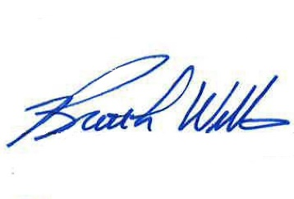

APPROVED:

___________________________________
Brett L. Wittner, Mayor

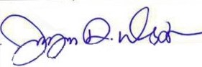
ATTEST:

_________________________________

Jayne Westman, City Clerk

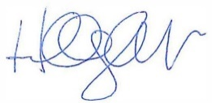
APPROVED AS TO FORM:

__________________________________

Hillary J. Evans, City Attorney

Publication Date:
Effective Date:

