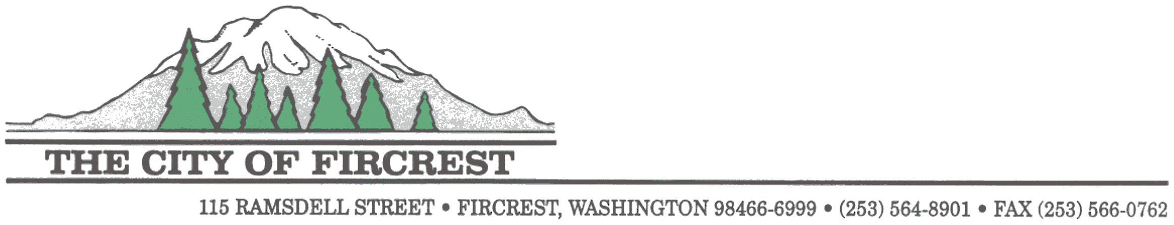

**2024 Calendar**

Funded by the

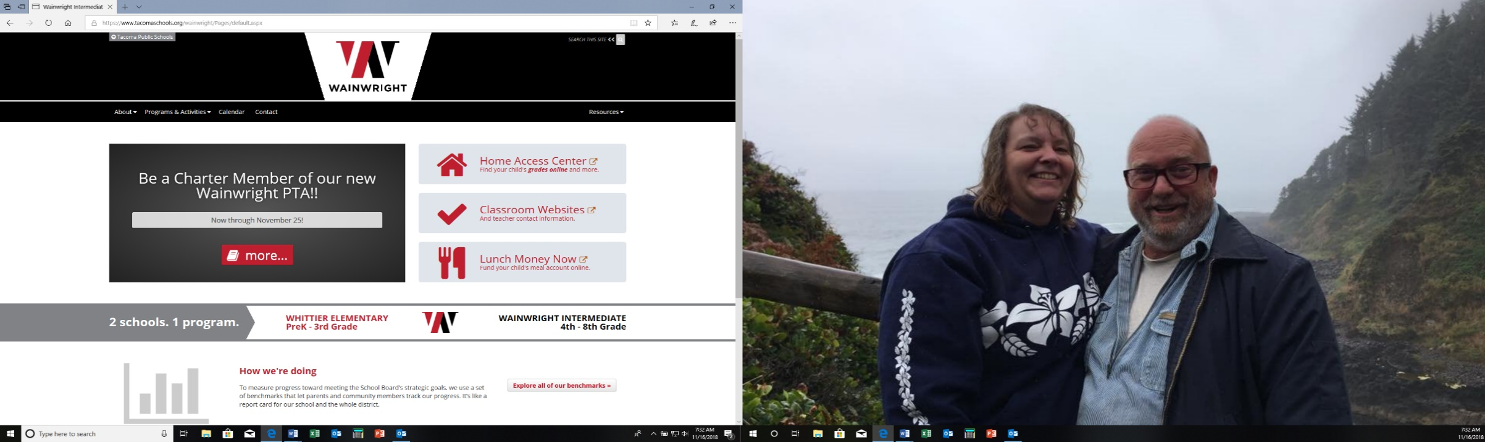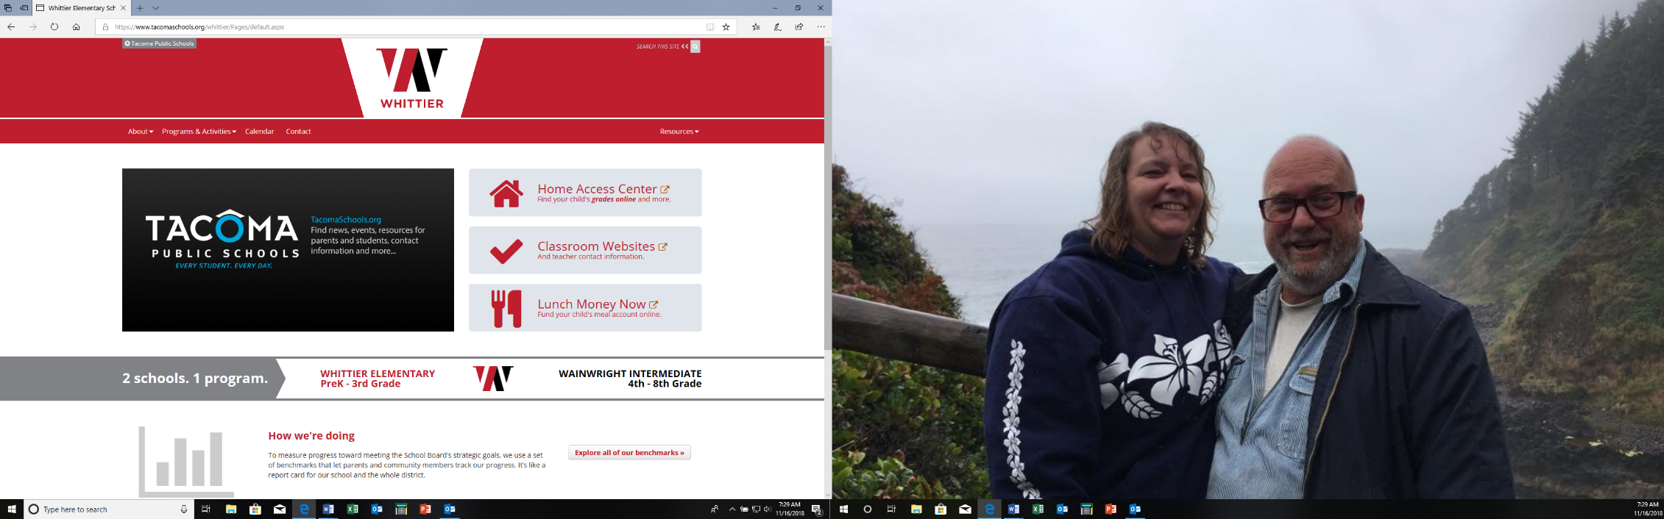

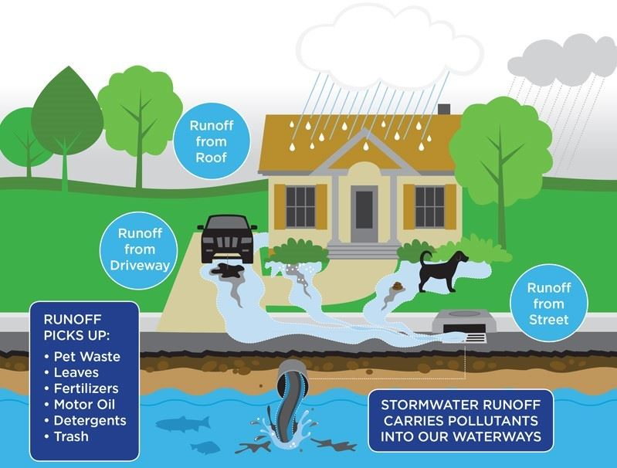

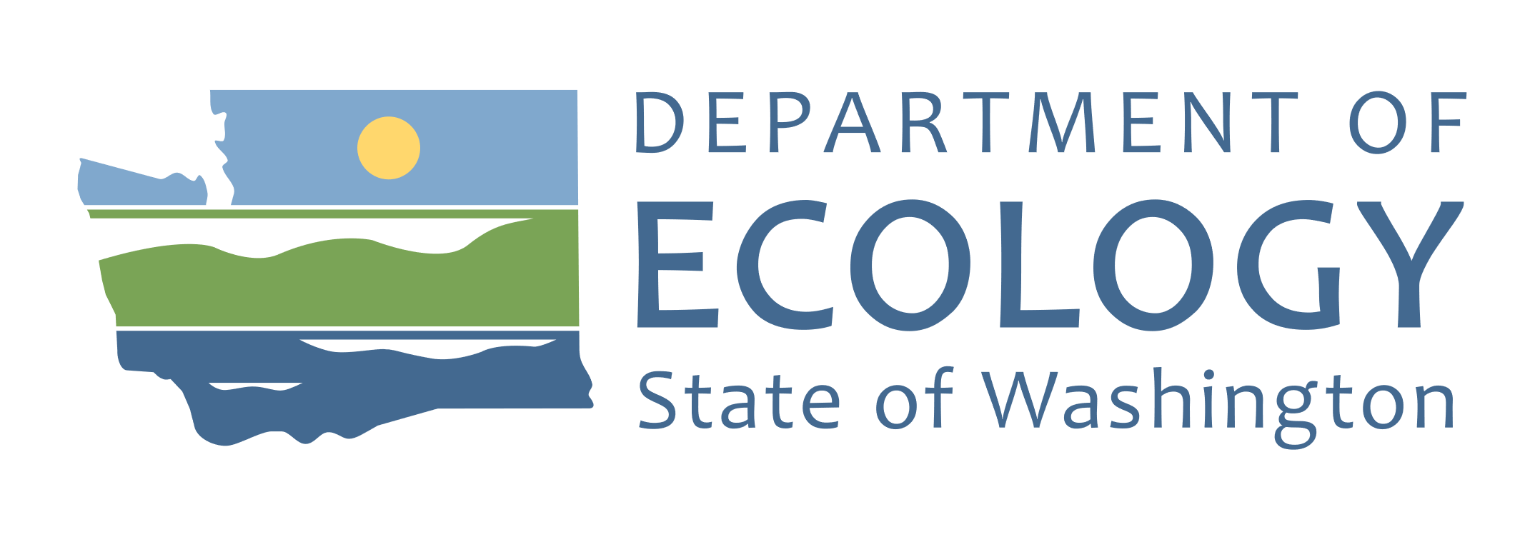

The City of Fircrest is partnering with Whittier Elementary, Wainwright Intermediate schools, the Department of Ecology (DOE), and Puget Sound Starts Here (PSSH) to raise awareness of how our everyday actions impact waterways in the Puget Sound region, educating what we can do to prevent pollution and why it is important.

Stormwater Capacity Grant