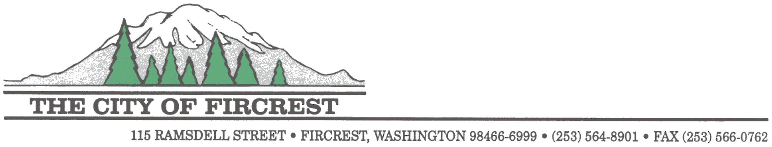This form is not a guarantee that a credit will be applied to your utility bill. You will be notified by mail if your request is either granted or denied. Only one leak adjustment will be allowed on one (1) billing period within a 12 month period and will only occur after all leaks have been repaired and verified by a City of Fircrest crew member. The basis for a leak adjustment shall be the normal consumption under similar operating conditions, typically averaging your previous two (2) years consumption history during the same time period.

WATER LEAK ADJUSTMENT REQUEST FORM

Name on Account: Account #:

Contact #: ( )

Service Address:

Date Leak Discovered / / Date Leak Repaired: / /

**Source of Leak**

⃝ Toilet ⃝ Irrigation ⃝ Pipe ⃝ Other

**Describe what was done to fix or correct the leak/water loss.**

What Documentation are you including with this request (**DOCUMENTATION IS REQUIRED**)

⃝ Plumber’s Invoice(s) ⃝ Hardware Receipt(s) ⃝ Photographs of Leak Area

As the customer and/or owner for the above listed service address, I hereby notify the city of Fircrest Utility Billing Department that I have sustained a water leak and to the best of my knowledge the leak has been repaired. I am requesting consideration of a leak adjustment under the City of Fircrest Water Leak Adjustment Policy. I confirm that the above and any attached information is true and accurate. I also acknowledge and understand that only one water leak adjustment may be applied to my utility account in any 12 month period.

Requester’s Signature Date

**Please Return Completed Form with Supporting Documentation to:**

The City of Fircrest

115 Ramsdell St

Fircrest, WA 98466

For questions call (253) 564-8900 (during normal business hours)

Or Email [publicworks@cityoffircrest.net](mailto:publicworks@cityoffircrest.net)

***FOR CITY USE ONLY***

A visual inspection of the water meter at the above location has been completed and it appears the leak has been repaired.

Crew Member Signature: Date:

⃝ Documentation Received

⃝ No Leak Adj Granted in the last 12 months for this location

⃝ Leak exceeded the allowable amount of consumption for this location

⃝ Approved ⃝ Denied

Bill Cycle to Adjust