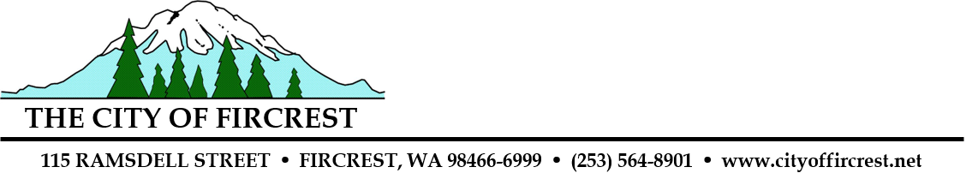

CITY OF FIRCREST
CITY COUNCIL PUBLIC HEARING ON
PRELIMINARY 2025 BUDGET REVENUE SOURCES

NOTICE IS HEREBY GIVEN that the Fircrest City Council will conduct a public hearing on October 22, 2024, commencing at 7:15 P.M., or soon thereafter, to accept public comments on the Preliminary 2025 Budget revenue sources. These meetings are open to the public. Citizens attending the public hearing have the right to provide written and oral comments. Written comments may be sent in advance of the hearing to:
City Clerk, 115 Ramsdell Street, Fircrest, WA 98466; phone: 253.564.8901; email: aburkhart@cityoffircrest.net. Visit the City’s website for more information at www.cityoffircrest.net.

-------------------------------------------------------------------------------------------------------------------------

CITY OF FIRCREST
CITY COUNCIL PUBLIC HEARING ON
PRELIMINARY 2025 BUDGET

NOTICE IS HEREBY GIVEN that the Fircrest City Council will conduct a public hearing on October 22, 2024, commencing at 7:15 P.M., or soon thereafter, to accept public comments on the Preliminary 2025 Budget. These meetings are open to the public. Citizens attending the public hearing have the right to provide written and oral comments. Written comments may be sent in advance of the hearing to:
City Clerk, 115 Ramsdell Street, Fircrest, WA 98466; phone: 253.564.8901; email: aburkhart@cityoffircrest.net. Visit the City’s website for more information at www.cityoffircrest.net.
-------------------------------------------------------------------------------------------------------------------------

CITY OF FIRCREST
CITY COUNCIL PUBLIC HEARING ON
PRELIMINARY 2025 BUDGET

NOTICE IS HEREBY GIVEN that the Fircrest City Council will conduct a public hearing on November 12, 2024, commencing at 7:15 P.M., or soon thereafter, to accept public comments on the Preliminary 2025 Budget. These meetings are open to the public. Citizens attending the public hearing have the right to provide written and oral comments. Written comments may be sent in advance of the hearing to:
City Clerk, 115 Ramsdell Street, Fircrest, WA 98466; phone: 253.564.8901; email: aburkhart@cityoffircrest.net. Visit the City’s website for more information at www.cityoffircrest.net.

