May 2nd, 2025

Dear Resident,

The City of University Place will soon be extending sanitary sewer within 37th Street West between 65th Ave West and 64th Ave West.

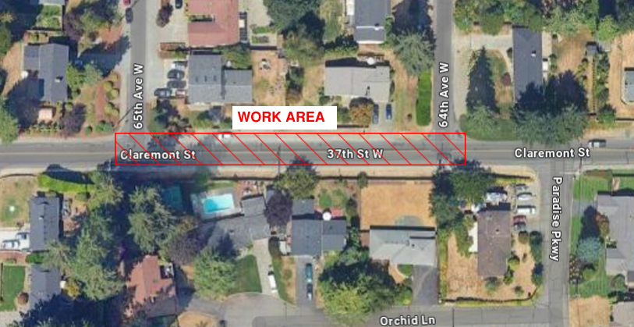

Our Contractor, Tucci and Sons LLC, is anticipating beginning work in this area on May 12th and will be closing this section of roadway during working hours to expedite production and shorten the impact to this stretch of roadway. Detour signs will be in place to direct traffic around the closure. Working hours for the project will be between 7:00 AM and 5:00 PM.

If you have any questions or concerns regarding construction activity, you can contact the City Inspector, Jordan Martin, at (253) 370-9776 or by email jmartin@cityofup.com or you can contact the Contractor’s representative, Robert Shelton, at (253) 922-6676 or by email at RShelton@tucciandsons.com

We appreciate your understanding and patience through construction.

Sincerely,

Kyle Mauren, P.E.
Senior Project Engineer
(253) 460-2531 / kmauren@cityofup.com

