Pasadena Avenue Sewer Main Pipe Bursting Replacement Project
The sewer main along the 700 block of Pasadena Drive was originally scheduled for replacement in 2027. However, due to ongoing and increasingly frequent blockage issues—primarily the result of root intrusion, offset joints, and general pipe deterioration along roughly 400 feet of the mainline—the project timeline has been advanced. Replacement work is now scheduled to begin on Monday, December 1st, and is expected to take up to two weeks to complete.
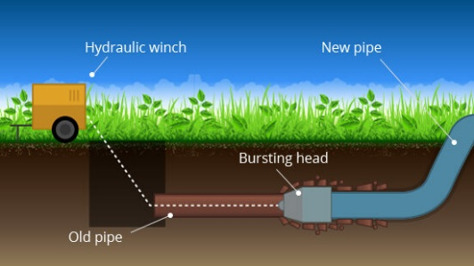
Drivers traveling near Pasadena & Ramsdell and Pasadena & Electron may experience intermittent, minor traffic delays. Most construction activity will occur within the planter strip adjacent to the roadway and along the edge of Fircrest Park, which should help minimize impacts to traffic flow.
We appreciate your patience as we work to improve reliability and reduce future service disruptions in this area.

Regents Traffic Signal Upgrade Project
A construction start date of Monday, December 1st, has been scheduled for the upgrade of the traffic signal equipment at the intersection of Regents Blvd and Electron/Golden Gate. This project is the result of close coordination between the City’s contractor and the City of Tacoma to modernize and standardize our signal infrastructure, following the recent signal controller failure at this intersection.
Construction is expected to take up to two weeks, weather permitting. Once completed, the new signal equipment will match the systems used at other signalized intersections throughout the City, improving long-term reliability and simplifying future maintenance.
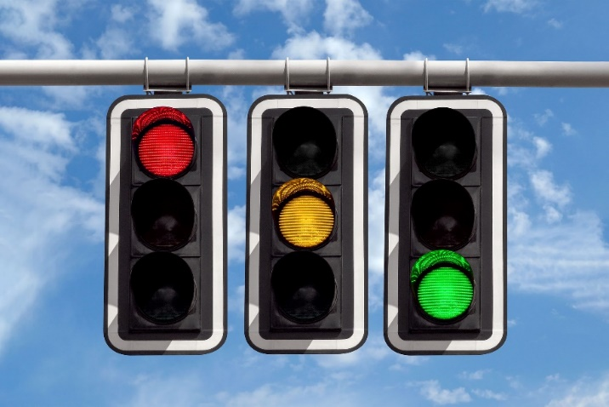
We appreciate your patience as we work to enhance safety, improve system performance, and minimize future service disruptions at this key intersection.
For more information, please contact Fircrest Public Works:
Office – (253) 564-8900
publicworks@cityoffircrest.net

