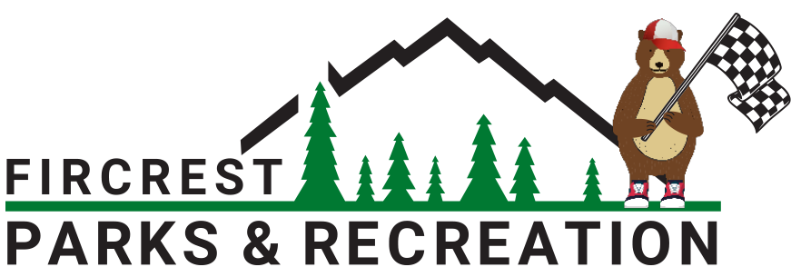

Fircrest Derby Day Build Requirements & Basic Safety

Encouraged: Creativity & Fun
Use recycled or repurposed materials.
Design your car to reflect a theme—goofy, cool, wild, or weird—it’s all welcome!
Work as a team (family, friends, scout group, etc.) to build something unique.
Remember: the goal is a fun and memorable experience, not just speed.

Size & Weight
Cars must meet the general size and weight requirements published by the City of Fircrest Parks & Recreation Department:
- Maximum width: 5 feet, measured from the outermost points of the car.
- Maximum length: 12 feet, including any bumpers or extended components.
- Must be able to clear the ramp.
- Must pass inspection.

Braking and Steering
- Brakes: Cars must include a reliable braking system that can bring the car to a stop safely. Foot, hand, or friction-style brakes are allowed.
  - Brakes must be able to hold the car when stationery.

- Steering: Steering mechanisms must be responsive and allow the car to stay within lane boundaries. Turning radius should be reasonable and stable (no sharp over-steering). Kingpin-style or other creative systems are allowed as long as they are safe and predictable. IMPORTANT: Front steering may only have a 1/2” gap in turn. Cars with a larger turning radius will be disqualified.
Steering Safety Tips
- Always limit how far wheels can turn to avoid flipping or oversteering.
- Secure all linkages with locking nuts or cotter pins.
- Test turning radius and return-to-center behavior before race day.
- Avoid steering designs that bind, wobble, or rub against the frame.
- Driver should practice multiple times behind the wheel braking, steering, etc. Race Day should NOT be the first time in the car driving.

Additional Build Requirements
- Padding & Edges: Please pad any hard edges inside the car where a driver might make contact. Sharp edges, glass, and unsecured decorations are not allowed.
- Spending limit: No more than $850 may be spent on the car, including materials and parts. This is to ensure fair competition and accessibility.
- Secure Construction: All parts must be firmly attached—no loose panels, bolts, or unsecured components. All materials used should be strong enough to safely carry the driver down the course.
- No Power Allowed: Cars must be gravity-powered only—no motors, pedals, or push assists once the race starts.
- Tow Eyebolts: A sturdy, large 1 inch eyebolt must be securely positioned at the front of the car to allow towing up the hill.
- Driver Identification: Drivers will be assigned numbers, which must be worn visibly on their uniforms. Numbers on the cars are for decoration and design purposes only and will not be used for identification.
- Cars must have a minimum of three wheels in contact with the track at all times for stability and safety.
- Cars must be powered solely by gravity—no kinetic energy storage, wind assistance, motors, pedals, or any form of propulsion is allowed.
- Cars must have functional brakes capable of bringing the vehicle to a complete stop in a controlled manner. Dragging feet or using body parts as brakes is prohibited (“Fred Flintstone” style braking is not allowed).
- Cars must be constructed to a workmanlike standard—all fasteners, welds, and structural components should be secure and durable. Unsafe or poorly constructed cars will not be allowed to race.

Prohibited Vehicles & Modifications
- No castering wheels
- Luge boards, skateboards, scooters, bicycles, or any similar wheeled devices do not qualify as derby cars and will not be permitted.
- No suspension systems, shock absorbers, or spring-loaded components that could provide an unfair advantage.
- No sharp or protruding objects that may pose a safety hazard to other participants or spectators.
- No offensive images or language on the car

Final Inspection & Compliance
- All cars will undergo a pre-race inspection to ensure compliance with these rules. Any car that does not meet the required standards will be disqualified from the competition.
- Any modifications made after inspection that violate the rules will result in immediate disqualification.
- Race officials have the final say on whether a car meets safety and design requirements.

Build Smart, Race Safe!
Follow these guidelines carefully to ensure fun and fair competition. We look forward to seeing your creativity and craftsmanship on race day!

