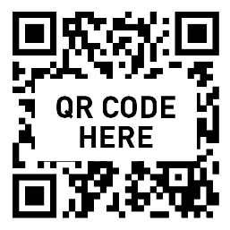

CITY OF FIRCREST - COMMUNITY CENTER
Bloodmobile | City of Fircrest - Community Center Fircrest

Thursday, September 17
9:00 am - 3:00 pm

Scan the QR code to book your one hour appt,
or click this link: bloodworksNW.org/giveblood.

Appointments are required for the best possible donation experience.
Same-day appointments available at most locations. Photo ID required.

Use Promo Code DRIVE-SEPT25 when scheduling your appointment at our blood drive
in September and you’ll receive 25 bonus points in Bloodworks’ new Donor Rewards Club.
Learn more at bloodworksNW.org/rewardsclub

